# **Task CLI day 2**

## **Problem 1 - Install oh-my-zsh**

I'm using windows for the OS

* Install Debian wsl in microsoft store
* WSL setting instructions on Tutorial https://dev.to/vsalbuq/how-to-install-oh-my-zsh-on-windows-10-home-edition-49g2
* Here is the result screenshoot

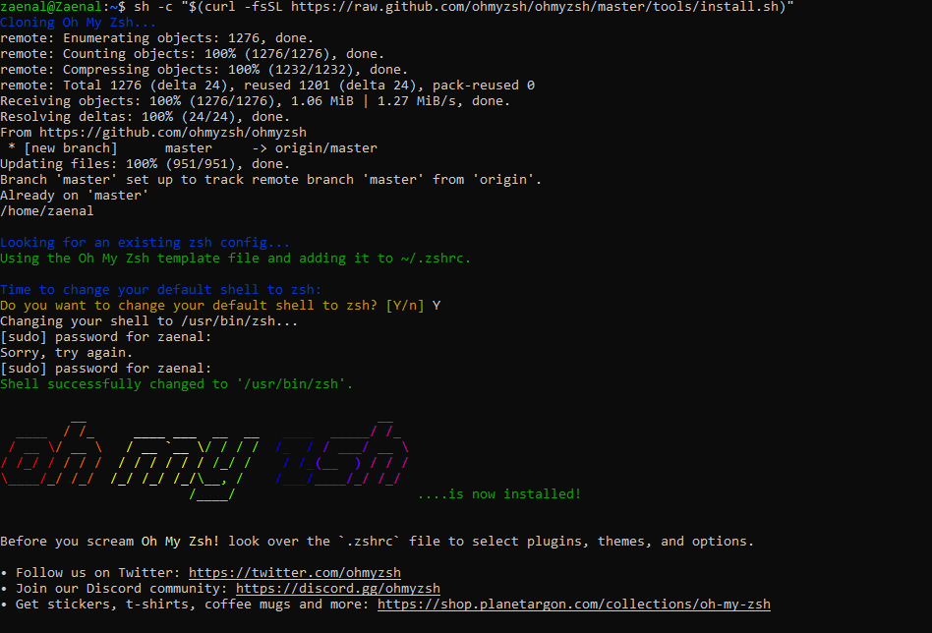

* File automate

